**Checklist Execution Assistant**

Checklist Execution Assistant Voice-enabled Checklist readout and verification assistant. It finds a checklist based on user's voice command, reads items from the checklists, waits for user to confirm every item and verifies item has been actually executed.

Voice interaction is handled by Alexa engine. It translates voice commands to requests for backend, which tracks which checklist and checklist item is being executed at the moment. Backend sends back result to Alexa and it is spoken to the user. There is also a web page that lists all checklists registered in the system and shows current state of execution. Items that are validated by the system have green text, items that are checked by the user but are not validated by the system have red text and successfully checked and verified items have green background.

**Technologies and Framework**

The demo was developed using the following technologies and libraries:

* Voice Assistant: AMAZON ALEXA (Python)
* Backend (Python)
  + Flask: <https://www.palletsprojects.com/p/flask/>
  + Flask Sockets: <https://github.com/heroku-python/flask-sockets>
  + JSON: checklist file
* GUI: it simulates the display screen in the cockpit
  + Bootstrap
  + CSS
  + HTML
  + Javascript

**Demo**

The demo is based on the interaction of 4 elements:

* Pilot: asks for a specific checklist and runs its instructions
* Alexa: waits for a specific command (**open the checklist**) and replies to the pilot with the checklist’s instructions
* Server: creates a web service for providing at Alexa and at GUI the access to the checklists
* 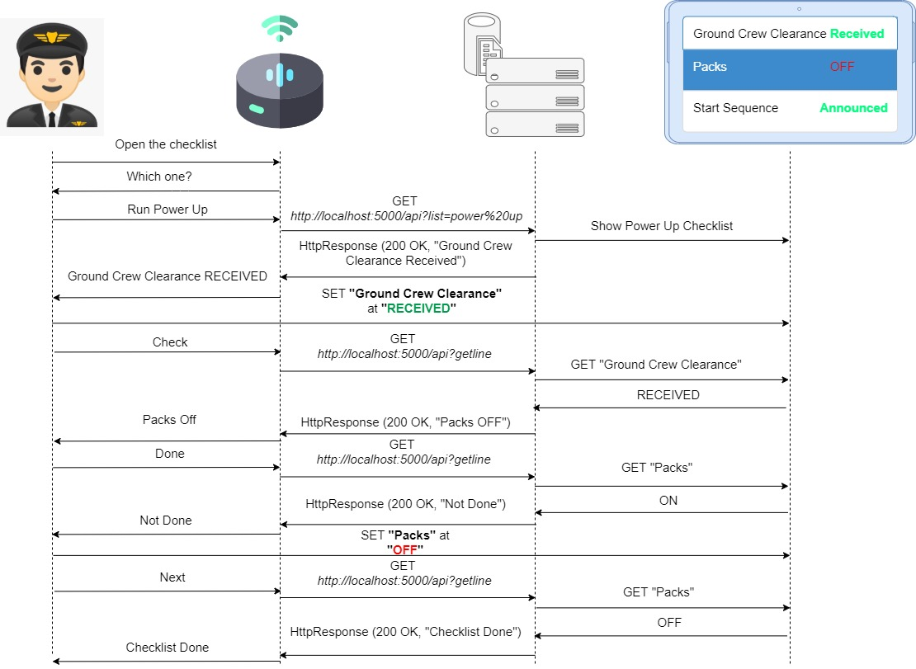GUI: is a web page to simulate the pilot’s display where the checklists are showed and the pilot can check its values.